Lab Assignment No: 03

Problem statement: Multithreading in Advanced Java

NAME: Chaitanya S. Joshi ROLLNO: 26

CLASS: SYMCA BRANCH: MCA BATCH: B1

DATE OF PERFORMANCE:03/03/2021

Question

**1)Implement Producer Consumer Problem using multithreading**

**2)Create an Application to display the table of different numbers using multithreading.**

**3)Create an Application to display even and odd numbers till number X input by user, Using multithreading.**

Solution:

**1)Implement Producer Consumer Problem using multithreading**

import java.lang.*;

class Producer extends Thread

{

StringBuffer buffer;

Producer()

{

buffer = new StringBuffer(10);

}

public void run()

{

synchronized(buffer)

{

for(int i=0;i<10;i++)

{

try

{

buffer.append(i);

System.out.println("Produced item:"+ i);

}

catch(Exception E)

{

System.out.println(E);

}

}

System.out.println("Buffer is Full !");

buffer.notify();

}

}

}

class Consumer extends Thread

{

Producer p;

Consumer(Producer t)

{

p = t;

}

public void run()

{

synchronized(p.buffer)

{

try

{

p.buffer.wait();

}

catch(Exception E)

{

System.out.println(E);

}

}

for(int i=0;i<10;i++)

{

System.out.println(p.buffer.charAt(i)+" Product is consumed");

}

System.out.println("Buffer is Empty !");

}

}

public class ProducerConsumer {

public static void main(String args[])

{

Producer p = new Producer();

Consumer c = new Consumer(p);

Thread t1 = new Thread(p);

Thread t2 = new Thread(c);

t2.start();

t1.start();

}

}

Output:

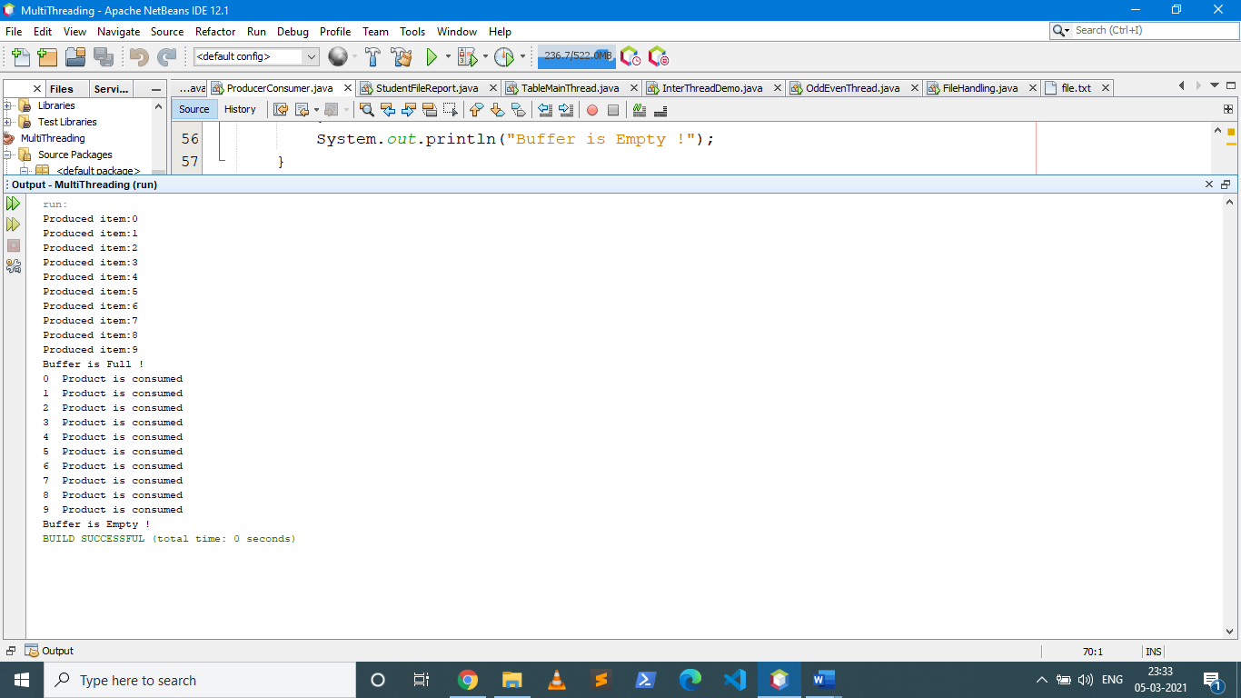

**2)Create an Application to display the table of different numbers using multithreading.**

import java.util.*;

class TableThread extends Thread {

int num;

TableThread(int n)

{

this.num = n;

}

public void run()

{

System.out.println("Printing table of :"+num);

synchronized(this)

{

try{

for(int i=0;i<=10;i++)

System.out.println(num+" x "+i+" = "+num*i);

}

catch(Exception e){

System.out.println(e);

}

}

}

}

class TableMainThread

{

public static void main(String args[]) throws InterruptedException

{

Scanner sc = new Scanner(System.in);

System.out.println("Enter Number for Table1 ");

int n1 = sc.nextInt();

System.out.println("Enter Number for Table2 ");

int n2 = sc.nextInt();

System.out.println("Enter Number for Table3 ");

int n3 = sc.nextInt();

TableThread ob1=new TableThread(n1);

TableThread ob2=new TableThread(n2);

TableThread ob3=new TableThread(n3);

ob1.start();

ob1.join();

ob2.start();

ob2.join();

ob3.start();

}

}

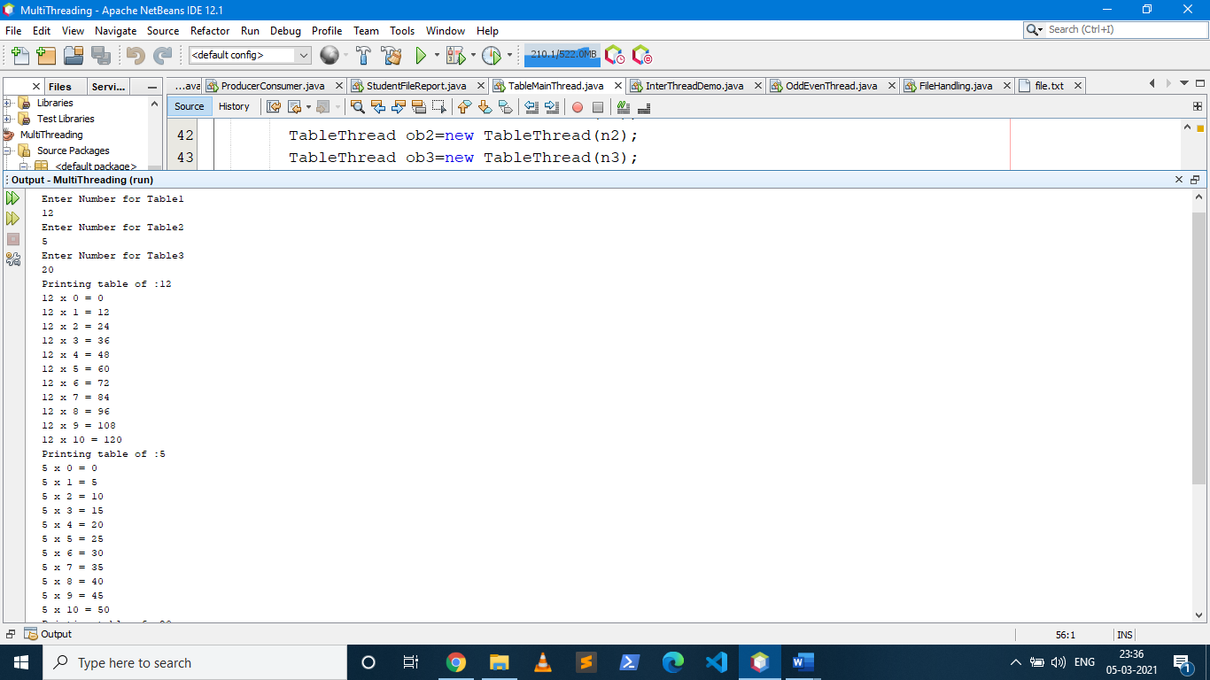

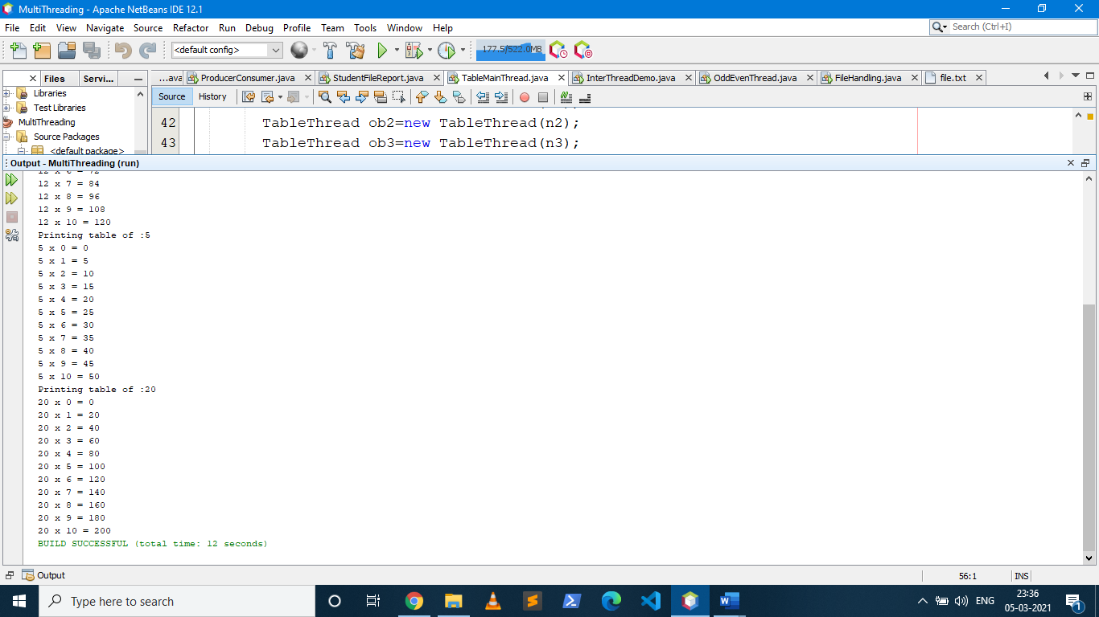

**3)Create an Application to display even and odd numbers till number X input by user, Using multithreading.**

import java.util.*;

public class OddEvenThread extends Thread

{

public static void main(String args[])

{

System.out.println("Enter a Number:");

Scanner sc = new Scanner(System.in);

int n = sc.nextInt();

Runnable r = new EvenNumber(n);

Thread t = new Thread(r);

Runnable r2 = new OddNumber(n);

Thread t2 = new Thread(r2);

t.start();

t2.start();

}

}

class EvenNumber implements Runnable

{

int n;

EvenNumber(int num)

{

this.n = num;

}

public void run()

{

for(int i=0;i<=n;i+=2)

{

System.out.print(" "+i);

}

}

}

class OddNumber implements Runnable

{

int n;

OddNumber(int num)

{

this.n = num;

}

public void run()

{

try

{

Thread.sleep(1000);

System.out.println("\n");

for(int i=1;i<=n;i+=2)

{

System.out.print(" "+i);

}

System.out.println("\n");

}

catch(Exception e)

{

System.out.println(e);

}

}

}

